Emily Backus and Zachary Mink
Mechanics 311, MATLAB 6
Due: March 21, 2012

Description of the System:
Angry Birds in Space is a video game that will be released on March 22, 2012. In the game, the player uses a slingshot to fire birds of various types at obstacles with the aim of destroying the evil pigs scattered throughout the obstacles. The collisions cause explosions which destroy the pigs. In this version, instead of being played on the earth with flat ground and constant acceleration due to gravity, it is played among asteroids of various sizes which each have their own gravitational fields.

Diagram of the System:
This is an expanded view of the entire level. The objects that are circled in red are fixed in space. 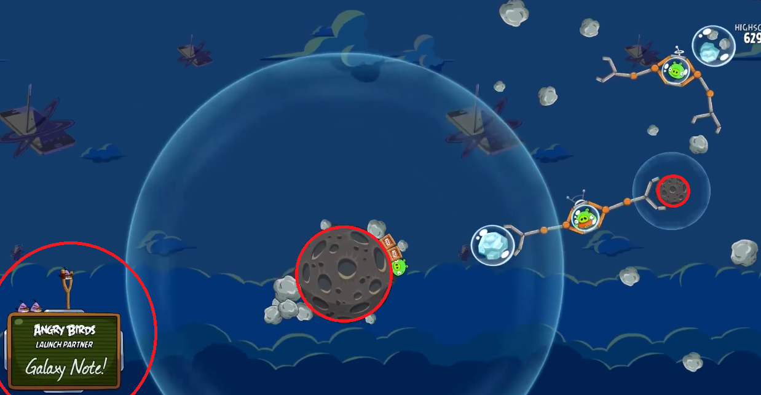

Here is a before-and-after image of a rock/rock-pile collision, with red arrows denoting velocities. (The bird/rock collision in the video we have is not the best for illustrative purposes.)
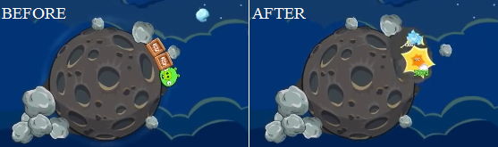
Goals:
Our primary goal is to model the trajectories and collisions of a bird into objects, such as a pile of rocks or a robotic arm, under the changing influences of local gravitational fields. If this is successful, we aim to optimize the effectiveness of the collisions by achieving maximum porcine destruction with the fewest birds possible.

Resources:
1. Physics simulations by Erik Neumann, as seen on the following websites:
http://www.myphysicslab.com/collision.html
http://www.myphysicslab.com/RollerFlight.html#collision_time
http://www.myphysicslab.com/contact.html
http://www.myphysicslab.com/collideSpring.html
http://www.myphysicslab.com/RollerFlight.html

2. Rhett Allain Wired article: The Physics of Angry Birds, seen here:
http://www.wired.com/wiredscience/2010/10/physics-of-angry-birds/

3. Angry Birds in Space trailer video from YouTube:
http://www.youtube.com/watch?v=10eHOnufWkA&feature=player_embedded

Note: Rocks are circles, covered in rock images. Collision events take place with circles. Note the overlap of the rocks in before image

